**Step 1 : Check the docker0 bridge**

ip a

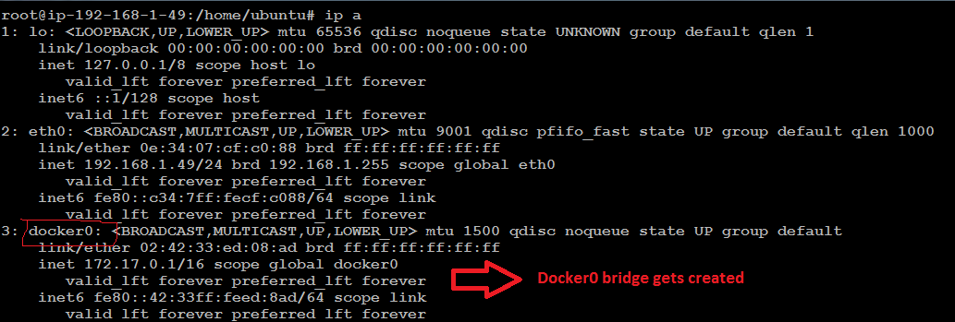

**Step 2 : Run a new container**

docker run -itd ubuntu:14.04 /bin/bash



**Step 3 : Login to the container**

docker exec -it f565bf38cf19 /bin/bash

**Step 4 : Verify the route for the container**

root@f565bf38cf19:/# route –n

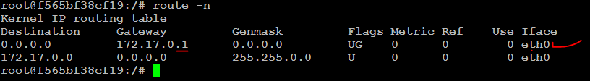

**Step 5 : Verify the interfaces**

ip a

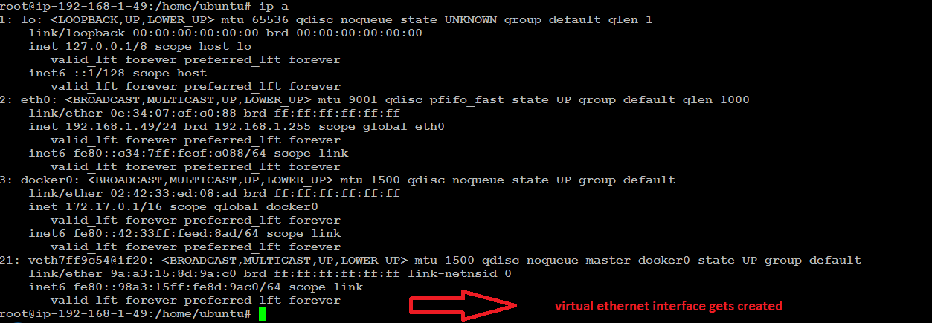

**Step 6 :** Running a container with desired hostname and container name

docker run -itd --name anil -h web ubuntu:14.04 /bin/bash

docker exec -it anil /bin/bash

hostname

Note : Once you launch new container a virtual Ethernet port on docker0 switch gets created

**Step 7 : Run a new container with port mapping**

docker run -d -p 5001:8080 tomcat:7

docker run -d -p 5002:8080 tomcat:7

**Step 8 : verify the port mapping**

docker port 09bd9a867ae4



**Step 9 : List the docker networks**

docker network ls

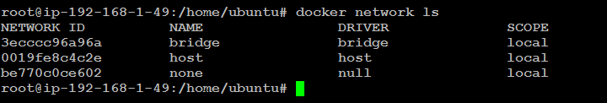

**Step 10 : Inspect details about your bridge docker0**

docker network inspect bridge

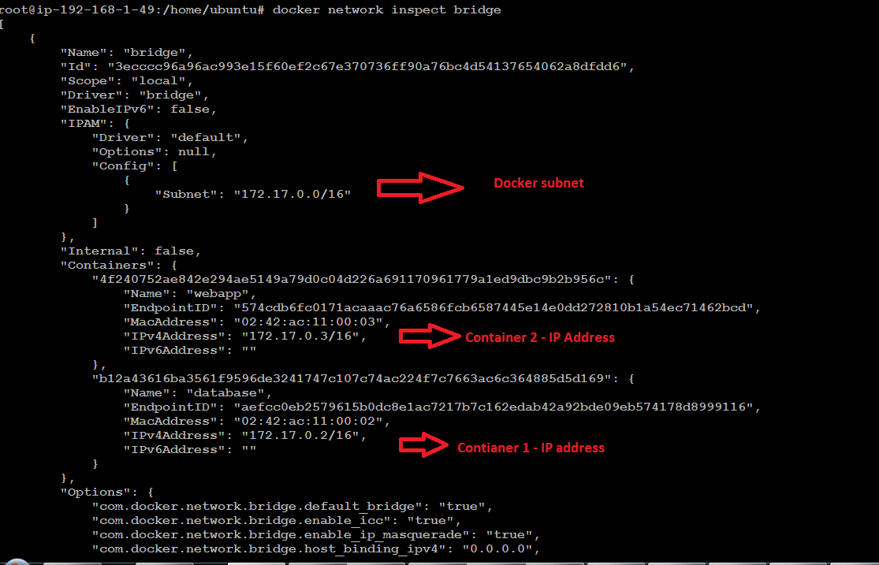

The Engine automatically creates a Subnet and Gateway to the network. The docker run command automatically adds new containers to this network.

**Step 11 : Create a two network**

docker network create --driver bridge network01

docker network create --driver bridge network02



**Step 12 : List available networks and verify new network is created**

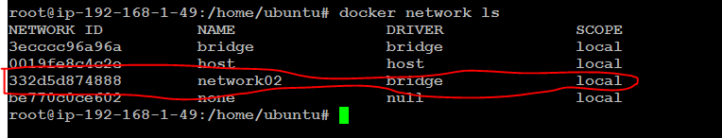

**Step 13 : Creating 2 new container in the new network created**

docker run --network=network01 -itd --name=container01 ubuntu:14.04

docker run --network=network02 -itd --name=container02 ubuntu:14.04

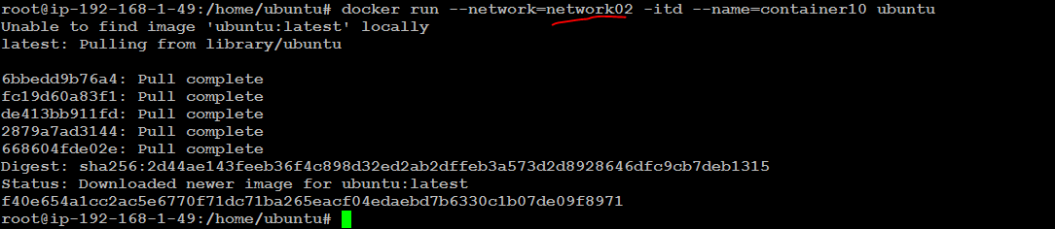

**Step 14 : List your running containers**

docker ps

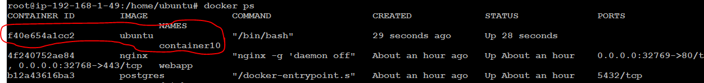

**Step 15 : Inspect both networks**

docker network inspect network01

docker network inspect network02

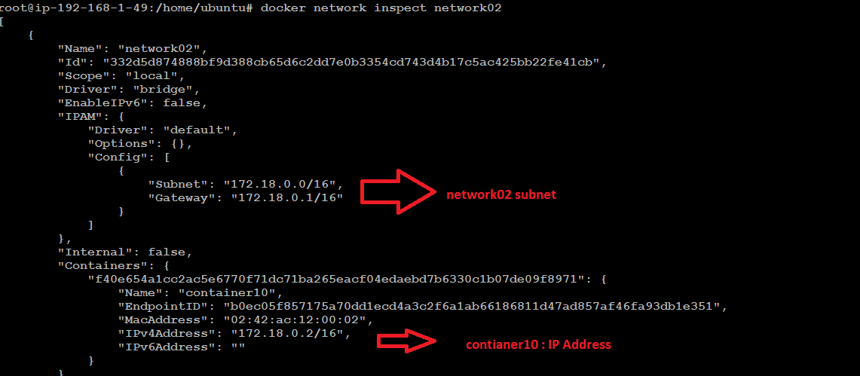

docker exec -it container01 /bin/bash

root@760ea20aaaff:/# ping 172.19.0.2

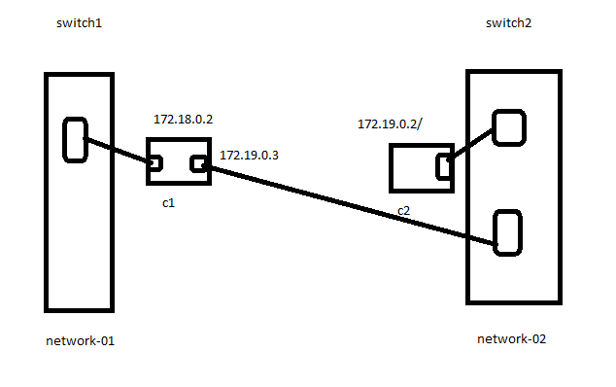

**Attach your container 01 to netowrk01**

docker network connect network02 container01

docker exec -it container01 /bin/bash

**root@8f6d85f7b54f:/# ping 172.19.0.2**

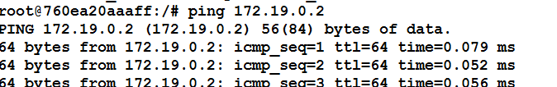

**Creating network with desired cidr**

docker network create --driver=bridge --subnet=10.0.1.0/24 --gateway=10.0.1.1 network04

docker network inspect network04

docker run --network=network04 --ip 10.0.1.4 -itd --name=container05 ubuntu:14.04

docker exec -it container05 /bin/bash